Name ______________________________________ Period _______Predicted Score______ Actual Score____/17
Total Score ________/34
The Church in the Middle Ages Pre-Test
- Place the church officials in its proper place in the Feudal pyramid. Leave the other areas blank.

Match the word on the right with its best description on the left.
- __________________ 10% of your income paid to the church
- __________________ Someone who did not believe in teachings of the church
- __________________ Formed for students who wanted to continue learning after
Cathedral School, which led to Universities.
- __________________ Courts meant to forcefully get heretics to confess.
6-8) Who did what?
Thomas Aquinas ________________________________________________________
_______________________________________________________________________
Pope Gregory VII ________________________________________________________
_______________________________________________________________________
Benedict ________________________________________________________
_______________________________________________________________________

The Crusades
Why were they fought? (2points) ______________________________________________________________________
__________________________________________________________________________________________________
What is one key event you can tell me about? (2 points) ___________________________________________________
____________________________________________________________________________________________________________________________________________________________________________________________________
What is one effect of the Crusades? (2 points) ____________________________________________________________
____________________________________________________________________________________________________________________________________________________________________________________________________

Look at the images below. Which one is Romanesque? Which one is Gothic? Label each, and give one reason why you chose how you did, based on the picture.

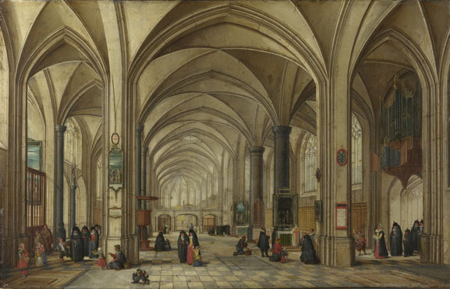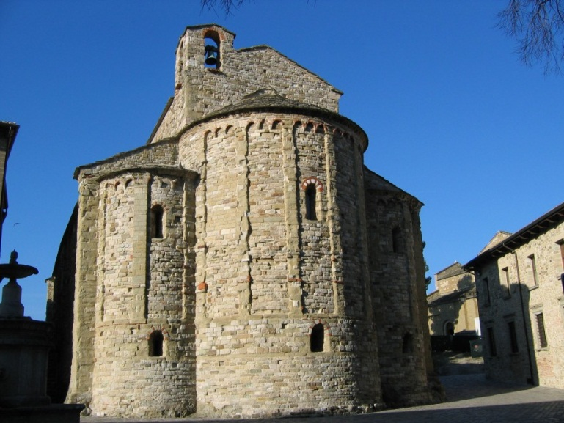
15) ________________________________ 16) ________________________________

17) Reason for your choice: ___________________________________________________________________________
__________________________________________________________________________________________________

