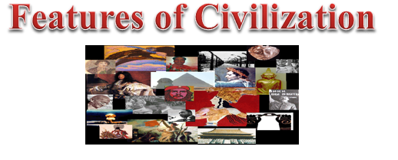
VIDEO REVIEW
Features of Civilization
- T F The wealthiest man in the community was the head of the government.
- T F Early civilizations practiced polytheism, praying to many gods.
- T F Artisans were skilled craftsmen who need a lot of training to do their job.
- T F The working class was at the top of the social classes in a civilization.
- T F Arts and public works were developed to make life better.
- T F Priests were trained to read and write.
- T F A city-state was a city and the surrounding lands.
- T F Empires were created by treaties among city-states.
- T F Nomads were civilized.
- T F Cultural diffusion is spread by trade, migration or warfare.

Use the FOCUS QUESTIONS to help you understand the features all civilizations have in common
__________ are the central feature of a civilization. They are centers of __________.  The first cities grew when ____________ began cultivating land along ___________ and produced ____________ foods.  The world’s first civilizations began along the ____________________ in the Middle East; the ________________ in Egypt; along the ______________ in India; and the ______________ in China. | ____________ or ____________ ruled many of the world’s first communities.  The central government coordinated the ______________ of large amounts of __________. Governments brought together people for building ____________, issuing __________, collecting __________ and organizing systems of ____________.  ___________ and ___________ emerged as the main leaders.
Most early peoples were _________________, which meant they believed in __________ gods.  Early worshippers believed the gods controlled __________________ and ____________ activities.  People tried to the favor of the gods with _____________, dances, prayers, building _____________ and _______________ animals. | ____________ people could not muster all the ____________ needed to make goods necessary to live in cities.  People began to ___________________ in certain jobs.  Specialization made people ___________________ on others for their needs.
In cities, people were ranked according to their ____________.  _____________ and _____________ were at the top level of society.  Wealthy _____________ and ___________ were at the next level.  The majority of the people in society were ____________ who produced _____________ for the city.  _________________ occupied the lowest social class. | Art and architecture expressed the talent _________________, and values of the people.  ________________ and _______________ dominated the city landscapes.  Buildings were built to show ______________ and the power of the ________________ and religion.
The ______________ ordered public works to be built.  Some projects were _______________ system, _____________, bridges and walls.  They were meant to ________________ the city.  The projects were often __________________. | ____________ kept the earliest writings to record amounts of ____________ collected, information about the _______________, rituals and _______________.  Early writing is the form of _______________ or simple _________________. It was found on ________________, ________________ and ___________________.  ________________ were taught to read and write and kept the records for the society.

