Name ____________________________________________________________ Period ______________
Feudalism Crossword Puzzle
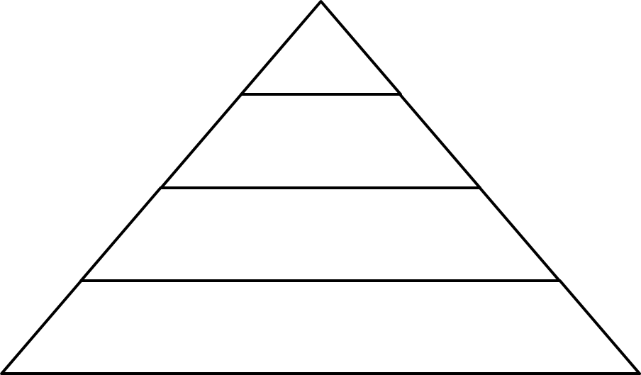
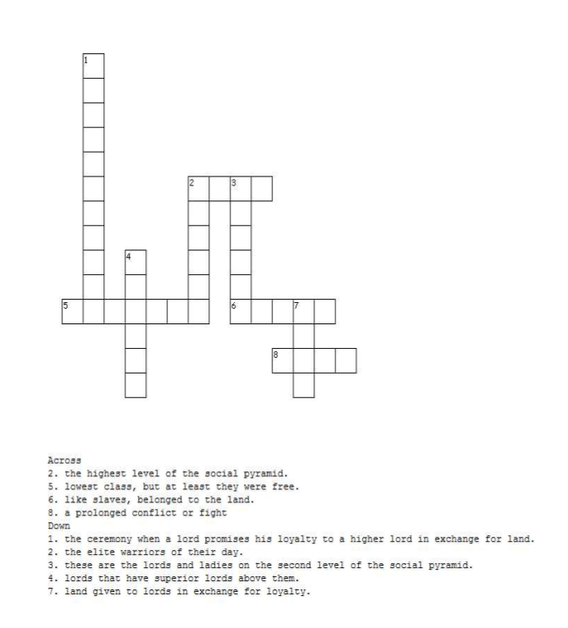
Across
2. the highest level of the social pyramid
5. lowest class, but at least they were free.
6. like slaves, belonged to the land.
8. a prolonged conflict or fight.
Fill in the Social Pyramid
Down
1. the ceremony when a lord promises his loyalty to a higher lord in exchange for land.
2. the elite warriors of their day.
3. these are the lords and the ladies on the second level of the social pyramid
4. lords that have superior lords above them.
7. land given to lords in exchange for loyalty.

