Name ______________________________________________________ Period __________
The Goths
- From which direction do the Goths originally migrate from? ____________________
- What are the two different groups of Goths? ______________________ ________________________
- What group of people are represented by the purple arrows? _______________________
- Where were they from? _______________________
- How did the Visigoths get into the Roman Empire? ________________________________________________________________________________________________________________________________________________________________________________________________
- How are the Visigoths treated by the Romans? Be specific. ________________________________________________
________________________________________________________________________________________________
- Who emerges as the leader of the Goths? _____________________________________
- What did he want for the Goths? ____________________________________________________________________
- On the map below, label Rome and Constantinople. Shade in the Roman Empire in red. Then draw in the migration patterns of the Goths in another color.
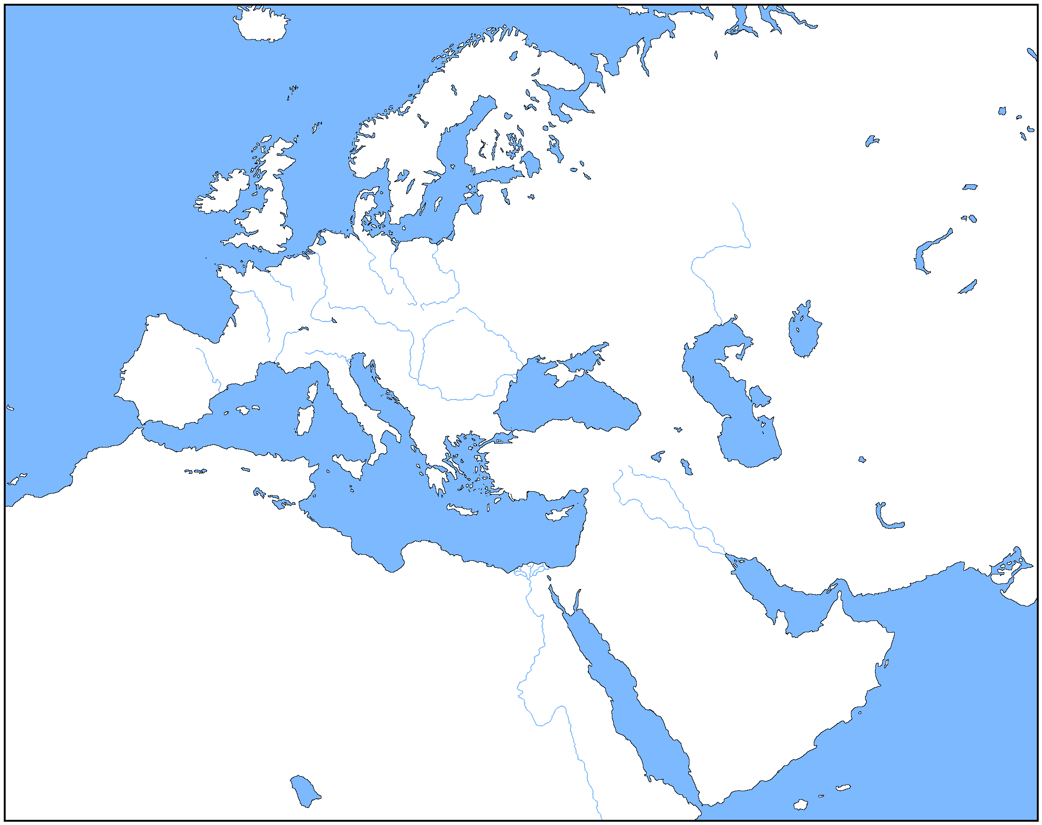
- In what year did the Visigoths sack Rome? ________________
- Where did the Visigoths eventually settle? __________________________
- Do you think the Goths were justified in their actions against Rome? Why or why not?
________________________________________________________________________________________________________________________________________________________________________________________________________________________________________________________________________________________________________________________________________________________________________________________________________________________________________________________________________________________________________________________________________________________________________________________________________________________________________________________________________________________________________________________________________________________________________________________________________________________

