Name _______________________________________________________________ Period __________
The Golden Age of Athens Study Guide
- Why did Athens need to be rebuilt? ______________________________________________
- Who was the leader of Athens that rebuilt the city? ________________________________
3. The public buildings in Athens were huge and made of ____________________?
4. The Parthenon was built to honor the goddess ______________________.
5. The _________________________ of Delphi was a priestess whose words were believed to come from _______________.
6. Greeks thought their gods and goddess lived on top of ___________________ _______________________.
7. Doric columns are known for their __________________________ look, __________________ columns have scrolls at the top, and _____________________________ columns are very fancy, often with flowers and leaves at the top.

8. Label the following sculptures
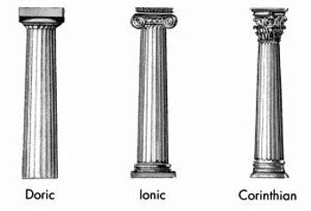

9. Greek sculptors loved to create statues in ________________________ poses.
10. Color in the part of the temple that is the pediment.

11. __________________________ was a philosopher who is known for asking many questions. The _______________________ Method is named for him, which is a form of dialogue that involves questioning and answering.

12. The Greeks valued sports, which shows that they valued ____________________ ____________________.

13. Actors wore _____________ in ancient Greek theater, which not only allowed men to portray women’s roles, but showed emotion to the audience.

14. The main purpose of a Greek _____________________ was to help understand the play.

15. The word ______________________ comes from Greek words meaning "love of wisdom.”

16. The Greeks agreed every four years to stop ____________________ for a brief period, so that they can let athletes go to the _________________________.

