The Crusades
As you have learned, religion played a very important role in shaping the Middle Ages. It influenced education, customs, morals, and routines of nearly everyone in Europe, and from time to time, the rule of a king and the laws of the church came into conflict with one another.
With the adoption of Christianity throughout Europe came the importance of protecting the religion itself, and the center of faith for followers of Christianity, Judaism, and Islam was the city of Jerusalem, located in the area known as Palestine. Jerusalem fell out of Christian control and became ruled by Arab invaders during the Early Middle Ages, but many religions (including Christianity) were not frowned upon by Jerusalem’s new rulers.
However, when control of the city shifted to the Turks in the eleventh century, Christianity and Judaism were persecuted. The city of Jerusalem was no longer a religious center for these two groups.
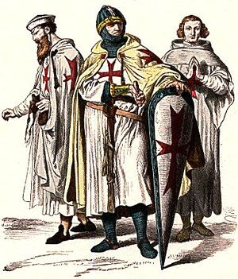
The Church, in its way, decided to take action, feeling it a duty to protect its holy city. It encouraged the leaders and people of Europe to take back the city, and in 1096 the First Crusade began, lasting until 1099. Religion and military force became very mixed up, and several groups or “orders” were formed during this time in history. These orders were made up of knights who believed in the cause of protecting the Holy Lands, and included The Knights of the Temple (also known as The Templars), The Knights of St. John, and the Order of Saint Mary of the Teutons (or The Teutonic Knights).
Each order had a different way of seeing things, despite sharing a common goal. Some took vows or promises to help Christian pilgrims, while others took vows of poverty (remaining poor) as a sign of devotion to their cause. However, among these orders, fighting was common, and this arguing between Crusaders often proved to be the cause of many problems. Rather than taking back Jerusalem, they seemed to be competing with each other.
Both peasants and knights joined the Crusades, each with different reasons for going. Some clearly felt that it was the right thing to do and wanted to return Jerusalem to its earlier state, making it safe for Christians to worship there. Others liked the idea of getting rich, finding new lands, and adventuring. However, the Crusades time and time again were unsuccessful. Cities in Palestine were captured and retaken by both sides, and this process happened over and over throughout the centuries.
It did not help that the Crusaders faced for some time a very powerful leader named Saladin the Great, who had already captured Syria, Egypt, and Iraq. Some kings, such as Richard I (also known as Richard the Lionheart) saw Saladin as a challenge, but despite repeated attempts to retake Jerusalem, the most that Richard the Lionhearted achieved was a treaty (or agreement) with Saladin.
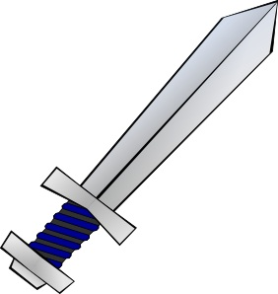
Over the years, popes called for further attempts to take back the Holy Lands. In total, there were nine of these journeys, some led by royals and some by common people. To give you an idea of the scope of the Crusades, consider just how many there were and how often they took place, usually in poor conditions and with equally poor results: First Crusade (1096-1099), Second Crusade (1144-1155), Third Crusade (1187-1192), Fourth Crusade (1202-1204), Fifth Crusade (1217-1221), Sixth Crusade (1228-1229), Seventh Crusade (1248-1254), Eighth Crusade (1270), and finally, the Ninth Crusade (1271-1272).
As you can see, some of these journeys to take back Jerusalem lasted much longer than others, and later voyages had as many political reasons as they did religious. Taking back Jerusalem not only meant winning a victory for Christianity, but it also meant governing an important area of land and the wealth tied to it.
In the end, the Crusades were unsuccessful. Rather than winning back Jerusalem, they ended up causing the deaths of many who went on such trips. However, they did bring about contact with the East, and education benefited from Arabic materials acquired during this time period, which were translated into Latin and improved Europe’s knowledge of many subjects.
Technological advancements were made as well, such as the development of the compass (leading to better maps) and weapons like the crossbow. As we have talked about before, with history, there are always ups and downs.

