Viking Flipped Lesson Questions

- What part of Northern Europe did the Vikings originate from?

- What three present-day countries make up this area?

- Why were fjords (bays or inlets) significant to the Vikings?

- Because their homeland had cold, long winters, steep mountains, and dense forests, Vikings were unable to ________________, so they left home to go on raids.

- The word “Berserker” means:
- Viking women
- The fiercest Viking warriors
- The insane Vikings
- A group that the Vikings fought

- Viking leaders were called ______________________

- Circle ALL of the responsibilities or opportunities that Viking women had. There may be more than one answer.
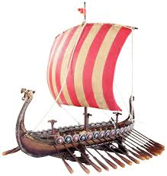
- Taking care of the home and children
- Attending public meetings
- Growing plants for medicine
- Owning property
- Going on raids

- Name three features of the Viking Longship’s design.

- Erik the Red founded ___________________, which was an icy wasteland.

- Leif Erikson founded Vineland, which today is the country ___________________.

- Using the map or the video, tell which group of Vikings (the Norwegians, the Danes, and the Swedes) raided or settled in the following countries.
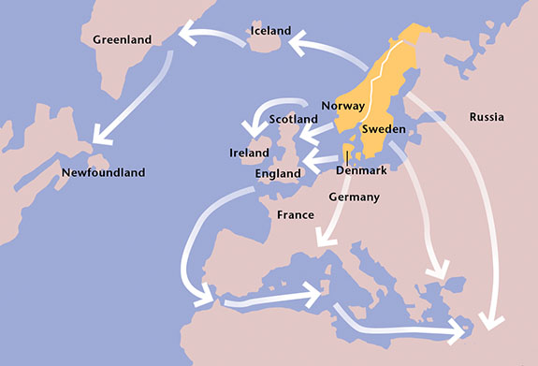

The _________________ went East to Russia and then South to the Black Sea.

The _________________ went West to Iceland, Greenland, and Newfoundland (Canada)

The _________________ went to West/South to England, Germany, France, and Italy

- Name one influence that the Vikings had on the rest of the world.

